Extra Credit

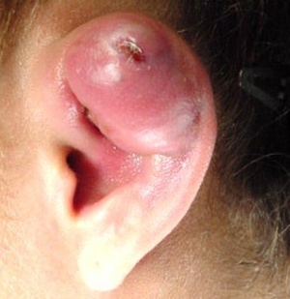Cartilage Piercing – What are the risks?

Perhaps you are considering a career in the medical field, or perhaps you are considering piercing your ear cartilage. Either way, today’s assignment will be of interest to you.

Medical professionals share what they’ve learned in medical journals. The Journal of Oral and Maxillofacial Surgery (JOMS) is one such periodical. Today you will read an article from JOMS about infection of auricular cartilage caused by ear piercing. The article begins with an introduction, continues with a case report, and then the authors discuss reviewed literature and treatments.

For your assignment you will:

1. Define 10 terms you don’t understand in the article. Look up definitions as you come across the terms while reading. The goal here is to expose you to medical terminology in use and make sense of it!
2. Write a letter to a friend who is thinking about getting his/her cartilage pierced. First explain the nature of ear cartilage and why it is different than the earlobe or other areas of skin. Next explain the risks, give a specific example of someone who got an infection, and tell them what to look out for. This letter should be longer than a page – typed. (1” margins, double spaced, Times New Roman 12 pt. font)
3. Do NOT copy and paste ANYTHING from the article. NO QUOTES. You may summarize or paraphrase where needed.
4. Turn in your defined words and letter.

Image credit: <http://www.primehealthchannel.com/wp-content/uploads/2010/10/ear-cartilage-piercing-infection.jpg>