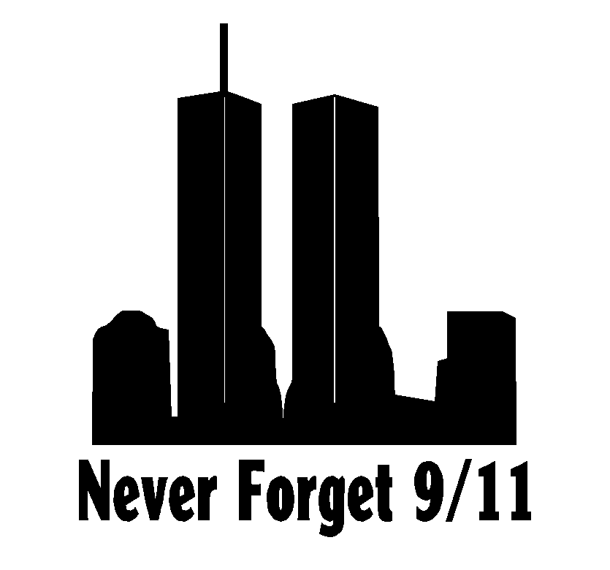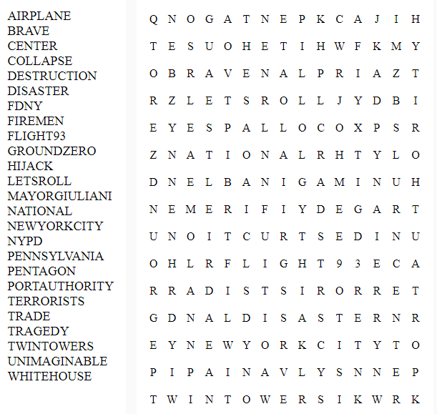NAME_________________________________________________ CLASS______________

**Remembering 9-11**