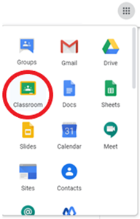

**School@Home: Accessing Google Classroom**

Students will access all assignments through Google Classroom. Once a student signs into his/her JNHS Google account, simply click on the navigation cube in the upper, right-hand corner and select Classroom.

**School@Home: Policies**

* **Engagement:** Students should plan to spend 30+ minutes receiving instruction asynchronously each day. Additionally, students will need to allot sufficient time to complete daily assignments outside of instructional time.
* **Attendance:** Attendance will be tracked and recorded daily. If a student is engaged during the day, the student will be marked present. Engagement will be determined by any of the following statements: (1) progress in Google Classroom made that day, (2) progress from teacher/student interactions made that day, or (3) submission of assignments due that day.
* **Teacher Availability:** Conference periods are available Monday-Friday 10:00 – 10:40am. If a student needs to meet virtually to discuss coursework, the student should email the teacher at least 24 hours prior to schedule a Google Meet.
* **Assignments:** Coursework will be posted daily in Google Classroom. Assignments that span multiple days will include a due date when assigned. Students will have until midnight to complete assignments due on any given day.
* **Feedback:** Students and parents/guardians will receive weekly feedback through Google Classroom. Parents/guardians must accept the ‘Guardian Email Summary’ invitation in order to receive weekly updates. Summaries will include (1) missing work, (2) upcoming work, and (3) class activity. For additional information about how to receive this summary, see below.

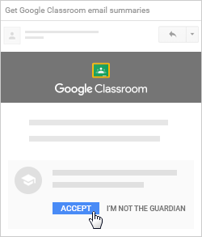**School@Home: How to Get Google Classroom Guardian Summaries**

To get email summaries of your student’s work, you must accept an email invitation from a teacher or administrator. You have 120 days to accept an invitation before it expires. You can unsubscribe from summaries or remove yourself as a guardian at any time.

1. The teacher or administrator emails you an invitation to join your student’s class.
2. In your email program, open your email invitation.
3. Click **Accept**.

If you’re not the guardian, click **I’m Not The Guardian**.

1. Click **Accept** to confirm.   
   When you accept an invitation, you and your student get an email confirmation.

**IMPORTANT:** After accepting, you will need to manage your summaries and select how often (daily, weekly) you would like to receive summaries. You can find complete step-by-step instructions at

<https://support.google.com/edu/classroom/answer/6388136?hl=en>