 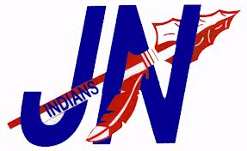 

**2018 Jim Ned Indian Track Schedule**

**Date Meet Location**

**2/23 Long Sleeve Relays Hamlin**

**3/2-3 Bluebonnet Relays Brownwood**

**3/8 Bangs Bangs**

**3/22 Merkel Merkel**

**3/29 Wall Wall**

**4/5 District Meet Stanton**

**4/16 Area Meet Jim Ned**

**4/27 & 4/28 Regional Meet ACU**

**Fri. & Sat.**

**5/11 & 5/12 State Meet Austin**

**Thur. & Sat.**

**Jim Ned Indian Middle School Track Schedule**

**Date Meet Location**

**2/22—Thurs. Jr Blue Bonnet Relays Brownwood**

**2/26—Mon. TBD TBD**

**3/6—Tues. Breckenridge Breckenridge**

**3/20—Tues. Badger Relays Merkel**

**3/27—Tues. Rock N Roll Relays Tuscola**

**4/12—Thurs. District Meet Merkel**